**LAB: 13**

Q.1 Write a program to find factorial using recursion

**Program**

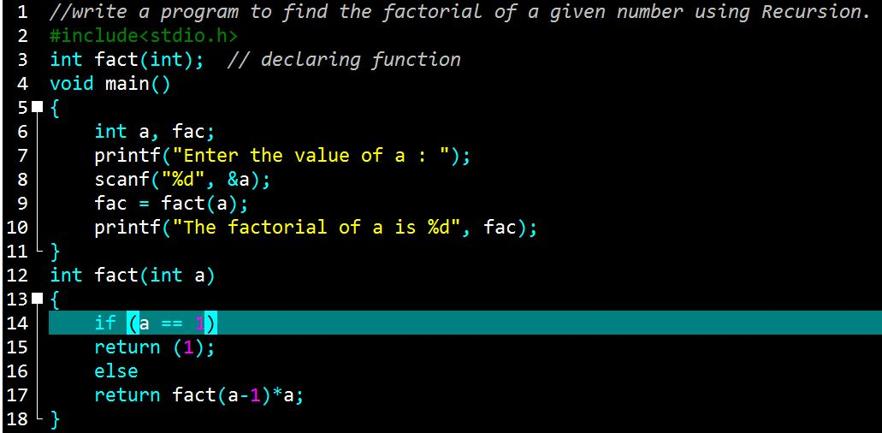

**Output**

